**ASSIGNMENT-15**

**Databases in Python**

Let’s connect our python application to databases:

1. Create a database. Create the following tables:

* Book
* Titles
* Publishers
* Zipcodes
* AuthorsTitles
* Authors

Refer to the diagram below

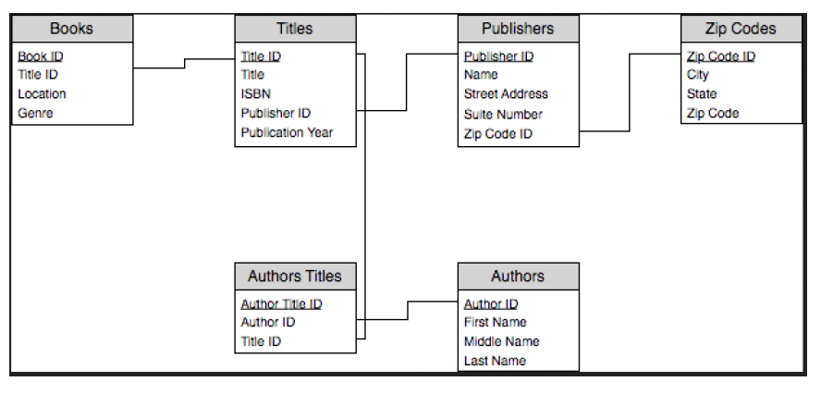

1. Insert values in the tables.
2. Update any values in any of the tables. Print the original and updated values.